**Project Report**

**Project Title: Auto Rice Mill Management System**

*Course title:* **Object Oriented Analysis and Design**

*Course code: CSE-314*

*3rd Year 1st Semester Examination 2023*

**Date of Submission**: 27-OCT-2024



**Submitted to-**

**Dr. Md. Mushfique Anwar**

Associate Professor

**Sarnali Basak**

Associate Professor

**Nadia Afrin Ritu**

Lecturer

**Lecturer***Department of Computer Science and Engineering*

*Jahangirnagar University*

*Savar, Dhaka-1342*

**Submitted By**

|  |  |  |  |
| --- | --- | --- | --- |
| **S.N** | Class Roll | Exam Roll | Name |
| 01 | 379 | 210899 | Shah Sultan |
| 02 | 383 | 210903 | Abdullah Nazmus-Sakib |
| 03 | 391 | 210911 | Khaled Mahmud Jon |
| 04 | 395 | 210915 | Tawhidul Islam |

**Chapter 1**

**1 Introduction 4**

* 1. Purpose 4
  2. Intended Audience 4
  3. Intended Use 4
  4. Product Scope 4
  5. Risk Definition 4

**Chapter 2**

1. **Overall Description 5**
   1. Operating Environment 5
      1. Hardware Requirements 5
      2. Software Requirements 5
      3. Operating System 5
   2. User Classes and Characteristics 5
      1. Farmers 5
         1. Characteristics 5
         2. Rules 5
      2. Mill Manager 6
         1. Characteristics 6
         2. Rules 6
      3. Customers 6
         1. Characteristics 6
         2. Rules 6
      4. Admin 6
         1. Characteristics 6
         2. Rules 7
   3. Constraints 7
      1. Technical constraints 7
      2. Budget constraints 7
      3. Resource constraints 7
   4. Assumptions 7
      1. Stable Internet Connection 7
      2. Responsive Design 7
      3. Third-Party API Availability 8

**Chapter 3 8**

1. **Requirements 8**
   1. Functional Requirements 8
   2. Non-Functional Requirements 9

**Chapter 4 10**

* **User Stories 10**

**Chapter 5 12**

* **Use Case Diagram 12**

**Chapter 6 13**

* **Use Case Specifications 13**

**Chapter 7 23**

* **Class Diagram 23**

**Chapter 8 24**

**Sequence Diagram 24**

**8.1 Farmer 24**

**8.2 Mill Manager 25**

**8.3 Customers 26**

**8.4 Admin 27**

**Chapter 9 28**

**State Chart Diagram 28**

**9.1. Farmers 28**

**9.2 Mill Manager 29**

**9.3 Customers 30**

**9.4 Amin 31**

**Chapter 10 32**

* **Database Schema 32**

Chapter 1

**Introduction**

* 1. **Purpose**

The Auto Rice Mill Management System is designed to simplify and automate the entire journey of rice production, from collecting paddy from farmers, milling it, to selling the finished rice online. This platform brings together farmers, mill managers, and customers in one place, making it easier for everyone to connect and do business.

Farmers can easily sell their paddy, mill managers can efficiently handle processing and stock management, and customers can buy rice with just a few clicks. The system not only saves time but also ensures smooth communication, greater transparency, and real-time updates for everyone involved. It makes the whole process—from farm to table—faster, clearer, and more convenient for all.

* 1. **Intended Audience**

The **intended audience** for the Auto Rice Mill Management System includes **farmers**, **mill managers**, **customers**, and **administrators**, who seek an efficient, streamlined way to handle rice sales, processing, and management through a centralized digital platform.

* 1. **Intended Use**

The **intended use** of the Auto Rice Mill Management System is to provide a digital platform for managing the entire process of **buying rice from farmers**, **milling it**, and **selling it to customers** online. The system facilitates **account creation**, **order placement**, **payment processing**, **inventory management**, **delivery tracking**, and **customer feedback**, streamlining communication and transactions between farmers, mill managers, and customers.

* 1. **Product Scope**

The Product Scope of the Auto Rice Mill Management System includes creating a unified platform that connects farmers, mill managers, and customers to streamline the process of selling, milling, and purchasing rice. The system enables farmers to list their paddy for sale, manage deliveries, and receive payments. Mill managers can oversee rice processing, manage inventory, and track sales. Customers can browse rice varieties, place orders, make payments, and track deliveries. Additionally, the platform offers real-time updates, reporting features, and customer feedback to ensure seamless transactions and improve service efficiency.

* 1. **Risk Definition**

The Auto Rice Mill Management System is a digital platform connecting farmers, mill managers, and customers. It streamlines the process of selling, milling, and purchasing rice, facilitating order management, payment options, inventory tracking, and customer feedback, while enabling efficient communication and operations within the rice supply chain.

Chapter 2

**Overall Description**

2.1 **Operating Environment**

This section provides an overview of the operational environment in which the system will be deployed and run. It outlines the hardware, software, networking, and other components required to ensure the reliable and secure functioning of the web application.

2.1.1 **Hardware Requirements**

* Virtual Machines: Running of cloud infrastructure.
* Load Balancer: Distributing incoming traffic across multiple VMs to ensure optimal resource utilization and high availability.

2.1.2 **Software Requirements**

* Front end: HTML, CSS and React framework will be used for development purposes.
* Database: MySQL relational database to store and manage application data.
* Web Server: Nginx will be used to serve static files and handle incoming HTTP requests.

2.1.3 **Operating System**

The servers will run on the Linux operating system, specifically Ubuntu Server 20.04 LTS. This choice provides a stable and well-supported environment for hosting the web application.

2.2 **User Classes and Characteristics**

**2.2.1 Farmers**

**2.2.1.1 Characteristics:**

* + Can create and manage their accounts.
  + List harvested paddy for sale, including quantity and quality details.
  + Request mill managers to purchase their products.
  + Choose delivery options (self-delivery or mill manager’s pickup).
  + Select payment methods (cash on delivery or online payment).

2.2.1.2 **Rules:**

* + Must provide valid identification and farm details during account creation.
  + Must list accurate information about the paddy being sold.
  + Can only request one mill manager at a time for a product.
  + Delivery options must be selected prior to order submission.
  + Must adhere to the quality standards set by the mill manager.

2.2.2 **Mill Managers**

2.2.2.1 **Characteristics:**

* + Can create and manage accounts for different mills.
  + Review and approve orders from farmers.
  + Choose to buy products from farmers without prior requests.
  + Inspect delivered paddy for quality upon receipt.
  + Manage inventory and stock levels.
  + Generate sales and inventory reports.

2.2.2.1 **Rules:**

* Must approve or decline orders within a specified time frame.
* Must ensure fair pricing when purchasing from farmers.
* Must maintain accurate inventory records.
* Responsible for quality checks before accepting delivered paddy.
* Must communicate clearly with farmers regarding order status.

2.2.3 **Customers**

2.2.3.1 **Characteristics:**

* Can create and manage their accounts.
* Browse available rice varieties and check stock levels.
* Place orders online and choose payment methods.
* Track the status of their orders in real-time.
* Leave reviews and feedback on received products.

2.2.3.1 **Rules:**

* Must register with valid personal information to place orders.
* Can only order available rice varieties listed in the system.
* Must adhere to payment methods available at the time of order.
* Can leave feedback only after receiving the product.
* Must maintain a respectful tone when leaving reviews.

2.2.4 **Admins**

2.2.4.1 **Characteristics:**

* Manage user accounts for farmers, mill managers, and customers.
* Handle user reports and complaints.
* Send notifications and warnings to users.
* Ensure system security and data integrity.

2.2.4.1 **Rules:**

* Must verify user information during account creation and updates.
* Responsible for resolving user complaints in a timely manner.
* Can suspend or terminate user accounts for violations.
* Must maintain confidentiality of user data.
* Must regularly monitor system performance and user activity.

**2.3 Constraints**

This section outlines the various constraints that need to be considered during the development and operation of the system. These constraints define limitations or requirements that influence the design, functionality, and deployment of the application.

**2.3.1 Technical constraints**

The system must be compatible with the latest versions of commonly used web browsers such as Google Chrome, Microsoft Edge, Safari.

**2.3.2 Budget constraints**

The development of the system must adhere to the allocated budget of BDT X. This budget includes expenses related to software licenses, development tools, and personnel costs.

**2.3.3 Resource constraints**

The system will be hosted on a cloud-based server with allocated resources of X CPU cores, Y GB of RAM, and Z GB of storage. The development team must optimize code and configurations to ensure efficient resource utilization within these limits.

**2.4 Assumptions**

**2.4.1 Stable Internet Connection**

It is assumed that users accessing the system will have a stable internet connection with reasonable bandwidth.

**2.4.2 Responsive Design**

It is assumed that the system will incorporate responsive design principles to ensure proper rendering and usability across various screen sizes and devices, including desktops, tablets, and smartphones.

**2.4.3 Third-Party API Availability**

It is assumed that the external APIs (e.g. Bkash) used for data integration will be available and operational during the application’s usage. Contingency plans will be devised in case of API unavailability or changes that impact integration.

Chapter 3

Requirements

**3.1 Functional Requirements**

* **User Registration and Authentication**
  + Farmers, mill managers, customers, and admins must be able to create accounts with valid credentials.
  + Users must be able to log in and log out securely.
* **Farmer Features**
  + Farmers can list their harvested paddy for sale, including details like quantity, quality, and price.
  + Farmers can request mill managers to buy their products or allow mill managers to directly accept their offers.
  + Farmers can choose between self-delivery or requesting the mill manager to pick up the product, with cost deductions for delivery.
  + Farmers can select a payment method (cash on delivery or online payment) to receive their earnings.
* **Mill Manager Features**
  + Mill managers can review and approve or decline orders from farmers.
  + Mill managers can inspect the quality of paddy upon delivery.
  + Mill managers can manage inventory and categorize processed rice (e.g., white rice, brown rice).
  + Mill managers can generate reports on stock levels and sales.
* **Customer Features**
  + Customers can browse through available rice varieties, check stock availability, and place orders.
  + Customers can select payment methods (online or cash on delivery).
  + Customers can track the status of their orders in real-time.
  + Customers can leave reviews and feedback after receiving their orders.
* **Admin Features**
  + Admins can manage user accounts (farmers, mill managers, customers) and perform verification checks.
  + Admins can handle user reports, complaints, and send notifications or warnings to users.
  + Admins can monitor system performance and user activity for security purposes.
* **Order Management**
  + The system must track the entire order process from the farmer listing the product to the customer receiving the rice.
  + The system must provide real-time updates and notifications to users regarding their orders.

**Non-Functional Requirements**

* **Performance**
  + The system must handle a minimum of 500 concurrent users without significant performance degradation.
  + Order processing and updates should occur within 3 seconds for optimal user experience.
* **Security**
  + User data must be encrypted to protect sensitive information (e.g., passwords, payment details).
  + The system must implement secure payment gateways for online transactions.
  + Role-based access control must be enforced to ensure users can only access functionalities relevant to their roles.
* **Usability**
  + The user interface must be intuitive and user-friendly for all user classes (farmers, mill managers, customers, and admins).
  + The platform should be accessible on both desktop and mobile devices, providing a responsive design.
* **Reliability**
  + The system must have an uptime of at least 99.5% to ensure continuous operation.
  + Regular backups must be scheduled to prevent data loss.
* **Scalability**
  + The system should be designed to accommodate future growth, allowing for the addition of new features and an increasing number of users without significant rework.
* **Maintainability**
  + The system codebase should be well-documented to facilitate future maintenance and updates.
  + Any updates or changes should be deployable without significant downtime.
* **Compliance**
  + The system must comply with relevant data protection regulations (e.g., GDPR) to ensure user privacy and data handling standards are met.

Chapter 4

User Stories

**1. Farmer User Story:**

**Title**: As a farmer, I want to list my paddy for sale and manage the sale process so that I can sell my harvested rice efficiently.

**Story**:

As a **farmer**, I want to create an account on the system and list my harvested paddy for sale. I should be able to provide details like the quantity, quality, and price of my paddy. I want the option to either request a mill manager to buy my paddy or have mill managers directly accept my listing, even if I haven’t requested them. I want to choose the delivery method—either deliver the paddy myself or request the mill manager to pick it up at their own expense (with the delivery cost deducted from my payment). I also want to choose how to receive my payment, either through the delivery staff or an online transaction. Throughout the process, I want to receive notifications and be able to track the sale.

**2. Customer User Story:**

**Title**: As a customer, I want to browse rice varieties and place orders so that I can conveniently buy rice online.

**Story**:

As a **customer**, I want to create an account and log in to browse through the different rice varieties available for purchase. I should be able to see important details such as the type, quality, price, and stock availability. Once I’ve selected the rice I want, I want to be able to place an order and choose my payment method, either paying online or opting for cash on delivery. I also want to track the status of my order and delivery in real-time, and after receiving the rice, I want to leave feedback to share my experience.

**3. Mill Manager User Story:**

**Title**: As a mill manager, I want to manage orders from farmers and customers, oversee the milling process, and manage inventory so that I can run the rice mill efficiently.

**Story**:

As a **mill manager**, I want to manage the purchase of paddy from farmers by either responding to their sales requests or directly accepting their listed paddy. Once I’ve reviewed and approved an order, I need to track the delivery or collection of the paddy, inspect its quality upon arrival, and manage the milling process. After milling, I want to update the stock inventory with details of the processed rice. For customer orders, I want to arrange delivery, ensure the rice reaches them, and update the system accordingly. I also need the ability to generate reports on stock levels and sales.

**4. Admin User Story:**

**Title**: As an admin, I want to manage user accounts, handle reports, and monitor transactions so that the system operates smoothly.

**Story**:

As an **admin**, I want to manage the accounts of all users (farmers, mill managers, and customers). I should be able to create, update, or delete user accounts as needed. I also need to handle user reports and complaints, resolving any issues that arise, and send warnings or notifications to users when necessary. Additionally, I want to monitor all transactions on the platform and generate system-wide reports to ensure the smooth operation of the entire system.

**Chapter 5**

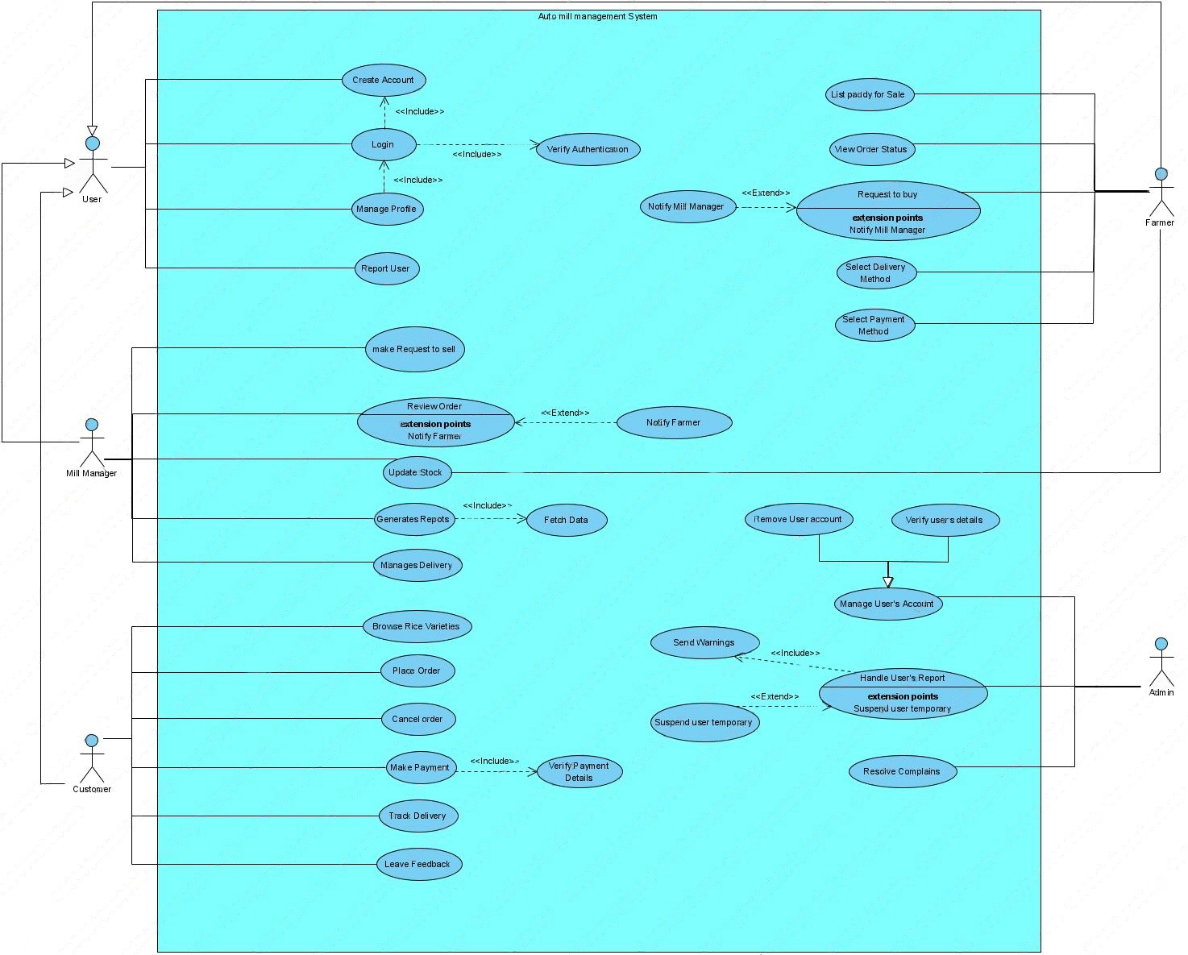**Use Case Diagram**

**Chapter 6**

**Use Case Specifications**

|  |
| --- |
| **Use Case ID:** UC1  **Use Case Name:** Create Account  **Actors:** Farmer, Mill Manager, Customer. |
| **Description:**   1. The user (Farmer, Mill Manager, Customer, Admin) accesses the registration page to create an account. 2. They provide details like name, contact info, email, password, and role-specific info (e.g., paddy details for farmers). 3. The system verifies the information. 4. If everything’s valid, the account is created, and a confirmation is sent to the user.   **Exceptions:**   1. **Invalid Info:** If required details are missing or incorrect, the system prompts the user to fix it. 2. **Email in Use:** If the email is already registered, the user is asked to log in or use a different email. 3. **System Error:** In case of a system issue, the user is notified that registration couldn’t be completed.   **Preconditions:**   * The user can access the registration form, and the system is working properly.   **Postconditions:**   1. **Success:** The user’s account is created, allowing access to the system. 2. **Failure:** If the registration fails, the user is shown an error and asked to try again. |

|  |
| --- |
| **Use Case ID:** UC2  **Use Case Name:** Login  **Actors:** Farmer, Mill Manager, Customer. |
| **Description:**   1. The user (Farmer, Mill Manager, Customer, or Admin) navigates to the login page. 2. The user enters their registered email and password. 3. The system verifies the credentials. 4. If valid, the user is granted access to their account and directed to their respective dashboard (Farmer, Mill Manager, Customer, or Admin).   **Exceptions:**   1. **Invalid Credentials:** If the email or password is incorrect, the system displays an error message and prompts the user to re-enter the correct details. 2. **Account Not Found:** If the email is not registered, the system suggests creating an account. 3. **Forgotten Password:** If the user has forgotten their password, they can request a password reset link.   **Preconditions:**   * The user has an active account and can access the login page. * The system is operational.   **Postconditions:**   1. **Successful Login:** The user is logged in and redirected to their dashboard based on their role. 2. **Unsuccessful Login:** If login fails, the user remains on the login page and is prompted to retry. |

|  |
| --- |
| **Use Case ID:** UC3  **Use Case Name:** Manage Profile  **Actors:** Farmer, Mill Manager, Customer. |
| **Description:**   1. The logged-in user (Farmer, Mill Manager, Customer, or Admin) navigates to the profile management section. 2. The user can view and update personal details such as name, contact information, email, password, and role-specific data (e.g., paddy details for farmers or mill information for managers). 3. The user submits the changes. 4. The system verifies and updates the profile details, reflecting the changes in the user’s account.   **Exceptions:**   1. **Invalid Input:** If any of the updated fields are invalid or incomplete, the system displays an error message and prompts the user to correct the information. 2. **Unauthorized Access:** If the user is not logged in or attempts to access another user's profile, the system blocks access and displays a warning. 3. **System Error:** If the system encounters an issue while updating the profile, the user is notified that the changes could not be saved.   **Preconditions:**   * The user is logged in and has access to their profile management page. * The system is operational.   **Postconditions:**   1. **Successful Update:** The user’s profile is updated, and a confirmation message is shown. 2. **Unsuccessful Update:** If the profile update fails, the user remains on the profile page and is asked to try again. |

|  |
| --- |
| **Use Case ID:** UC4  **Use Case Name:** Report User  **Actors:** Farmer, Mill Manager, Customer. |
| **Description:**   1. A user (Farmer, Mill Manager, or Customer) navigates to the "Report User" feature to report misconduct. 2. The user selects the report type (e.g., fraud, misconduct) and provides details. 3. The system submits the report and notifies the Admin. 4. The Admin reviews the report and takes appropriate action.   **Exceptions:**   1. **Incomplete Report:** If details are missing, the system prompts for more information. 2. **Unauthorized Access:** Non-logged-in users are redirected to the login page. 3. **System Error:** If the system fails, the user is notified to retry later.   **Preconditions:**   * The user is logged in and can access the "Report User" feature. * The system is operational.   **Postconditions:**   1. **Successful Submission:** The report is logged, and the Admin is notified. 2. **Failed Submission:** If the report fails, the user is asked to retry or contact support. |
| **Use Case ID:** UC5  **Use Case Name:** Make Request to Sell  **Actors:** Farmer, Mill Manager |
| **Description:**   1. The Farmer logs in and navigates to the "Make Request to Sell" feature. 2. The Farmer lists their paddy for sale by specifying details such as quantity, quality, and price. 3. The Farmer selects a Mill Manager to request a sale or leaves the option open for any Mill Manager to accept the offer. 4. The system sends the request to the selected or available Mill Manager. 5. The Mill Manager reviews and either accepts or rejects the request. 6. Upon acceptance, the sale process begins, and the Farmer is notified.   **Exceptions:**   1. **Incomplete Details:** If required information (quantity, quality, etc.) is missing, the system prompts the Farmer to complete the form. 2. **No Mill Manager Available:** If no Mill Manager is available, the system informs the Farmer. 3. **System Error:** If the system encounters an issue, the Farmer is notified that the request could not be submitted.   **Preconditions:**   * The Farmer is logged in and can access the "Make Request to Sell" feature. * The system is operational.   **Postconditions:**   1. **Successful Request:** The request is sent to a Mill Manager, and the Farmer is notified. 2. **Unsuccessful Request:** If the request fails, the Farmer is prompted to retry or contact support. |

|  |
| --- |
| **Use Case ID:** UC6  **Use Case Name:** Review Order  **Actors:** Mill Manager |
| **Description:**   1. The Mill Manager logs in and goes to the "Review Order" section. 2. They can see orders from Customers, including details like rice variety, quantity, price, and delivery status. 3. The Mill Manager checks stock levels and verifies that order details are accurate. 4. They can update the order status (e.g., processing, completed) as needed. 5. The Mill Manager can leave notes for staff or report any issues related to the order.   **Exceptions:**   1. **Order Not Found:** If there are no orders linked to the account, an error message is shown. 2. **Invalid Status:** If the Mill Manager tries to set an incorrect order status, they’ll be prompted to select a valid one. 3. **System Error:** If there's a technical issue, the Mill Manager is notified that the review could not be completed.   **Preconditions:**   * The Mill Manager must be logged in and able to access the "Review Order" feature. * The system must be operational.   **Postconditions:**   1. **Successful Review:** The order details are displayed, and the status can be updated. 2. **Unsuccessful Review:** If the review fails, the Mill Manager is prompted to try again or reach out for support. |

|  |
| --- |
| **Use Case ID:** UC7  **Use Case Name:** Update Stock  **Actors:**  Mill Manager |
| **Description:**   1. The Mill Manager logs in and navigates to the "Update Stock" section. 2. They view the current inventory levels for different rice varieties. 3. The Mill Manager can add new stock, specifying details such as rice type, quantity, and quality. 4. They can also remove or adjust existing stock levels as needed. 5. The system updates the inventory records and notifies the Mill Manager of the successful update.   **Exceptions:**   1. **Insufficient Details:** If required information (like quantity or rice type) is missing, the system prompts for completion. 2. **Invalid Stock Adjustment:** If the Mill Manager attempts to set an invalid stock level (e.g., negative quantity), an error message is shown. 3. **System Error:** If a technical issue occurs, the Mill Manager is notified that the stock update could not be completed.   **Preconditions:**   * The Mill Manager is logged in and has access to the "Update Stock" feature. * The system is operational.   **Postconditions:**   1. **Successful Update:** The stock levels are adjusted in the inventory system, and a confirmation is displayed. 2. **Unsuccessful Update:** If the update fails, the Mill Manager is prompted to try again or contact support. |

|  |
| --- |
| **Use Case ID:** UC8  **Use Case Name:** Manage Delivery  **Actors:**  Mill Manager |
| **Description:**   1. The Mill Manager logs in and navigates to the "Manage Delivery" section. 2. They can view all pending delivery requests from Farmers and Customers. 3. The Mill Manager reviews delivery details, including pickup location, delivery address, and order specifics. 4. The Mill Manager assigns delivery personnel or schedules the delivery. 5. They can update the status of the delivery (e.g., pending, in transit, completed) as needed. 6. The system sends notifications to relevant parties (Farmers, Customers, and delivery staff) about the delivery status.   **Exceptions:**   1. **No Pending Deliveries:** If there are no delivery requests, the system displays a message indicating there are no deliveries to manage. 2. **Invalid Delivery Status:** If the Mill Manager attempts to set an invalid status, an error message is shown. 3. **System Error:** If a technical issue occurs, the Mill Manager is notified that the delivery management could not be completed.   **Preconditions:**   * The Mill Manager is logged in and has access to the "Manage Delivery" feature. * The system is operational.   **Postconditions:**   1. **Successful Management:** Delivery details are updated, and notifications are sent to all parties involved. 2. **Unsuccessful Management:** If the management action fails, the Mill Manager is prompted to try again or contact support. |

|  |
| --- |
| **Use Case ID:** UC9  **Use Case Name:** Generate Reports  **Actors:**  Mill Manager |
| **Description:**   1. The Mill Manager logs in and goes to the "Generate Reports" section. 2. They select the report type (e.g., sales, inventory, delivery) and set the date range and filters. 3. After submitting the request, the system compiles the data and generates the report. 4. The report appears on the screen and can be downloaded or printed. 5. The Mill Manager may receive a notification when the report is ready.   **Exceptions:**   1. **No Data Available:** If there’s no data for the chosen criteria, a message informs them of this. 2. **Invalid Parameters:** An error message appears if invalid filters or dates are entered. 3. **System Error:** If there's a technical issue, the Mill Manager is notified that the report generation failed.   **Preconditions:**   * The Mill Manager is logged in and has access to the reporting feature. * The system is functioning properly.   **Postconditions:**   1. **Successful Generation:** The report is successfully created and accessible. 2. **Unsuccessful Generation:** If it fails, the Mill Manager is prompted to try again or seek support. |

|  |
| --- |
| **Use Case ID:** UC10  **Use Case Name:** Browse Rice Varieties  **Actors:**  Customer |
| **Description:**   1. The Customer logs in and navigates to the "Browse Rice Varieties" section. 2. They can view a list of available rice varieties, including images, descriptions, and prices. 3. The Customer can filter the rice varieties by type, price range, or availability. 4. They can click on any rice variety to view detailed information, including quality specifications and customer reviews. 5. The Customer may add rice varieties to their cart for future purchase.   **Exceptions:**   1. **No Rice Varieties Available:** If there are no rice varieties listed, the system displays a message indicating that no options are available. 2. **System Error:** If there’s a technical issue, the Customer is notified that browsing could not be completed.   **Preconditions:**   * The Customer is logged in and has access to the browsing feature. * The system is operational.   **Postconditions:**   1. **Successful Browsing:** The Customer can view and select rice varieties to consider for purchase. 2. **Unsuccessful Browsing:** If browsing fails, the Customer is prompted to try again or contact support. |

|  |
| --- |
| **Use Case ID:** UC11  **Use Case Name:** Place Order  **Actors:**  Customer |
| **Description:**   1. The Customer logs in and checks their cart for selected rice varieties. 2. They confirm quantities and choose a payment method (online or cash on delivery). 3. After entering delivery details and any special instructions, they submit the order. 4. The system processes the order, updates inventory, and sends a confirmation message.   **Exceptions:**   1. **Out of Stock:** If an item is unavailable, the Customer is alerted to adjust their order. 2. **Invalid Payment:** If payment fails, an error message prompts the Customer to retry or select another method. 3. **System Error:** Any technical issues will notify the Customer that the order couldn’t be placed.   **Preconditions:**   * The Customer is logged in and has items in their cart. * The system is operational.   **Postconditions:**   1. **Successful Order:** The order is confirmed, and the Customer receives a summary and tracking details. 2. **Unsuccessful Order:** If the order fails, the Customer is prompted to try again or contact support. |

|  |
| --- |
| **Use Case ID:** UC12  **Use Case Name:** Cancel Order  **Actors:**  Customer |
| **Description:**   1. The Customer logs in and navigates to the "Order History" section. 2. They select the order they wish to cancel from the list. 3. The Customer reviews the order details and confirms their decision to cancel. 4. The system processes the cancellation request and updates the order status. 5. The Customer receives a confirmation message regarding the cancellation.   **Exceptions:**   1. **Order Not Found:** If the selected order does not exist, an error message informs the Customer. 2. **Cancellation Period Expired:** If the order cannot be canceled due to time restrictions, the system notifies the Customer. 3. **System Error:** Any technical issues will alert the Customer that the cancellation could not be completed.   **Preconditions:**   * The Customer is logged in and has placed orders. * The system is operational.   **Postconditions:**   1. **Successful Cancellation:** The order status is updated, and the Customer receives a confirmation message. 2. **Unsuccessful Cancellation:** If the cancellation fails, the Customer is prompted to try again or contact support. |

|  |
| --- |
| **Use Case ID:** UC13  **Use Case Name:** Make Payment  **Actors:**  Customer |
| **Description:**   1. The Customer logs in and navigates to the "Order Summary" after placing an order. 2. They select their preferred payment method (credit card, debit card, or cash on delivery). 3. If choosing online payment, the Customer enters payment details and confirms the transaction. 4. The system processes the payment and verifies the transaction. 5. The Customer receives a confirmation message once the payment is successful.   **Exceptions:**   1. **Invalid Payment Details:** If the entered payment information is incorrect, the system prompts the Customer to re-enter their details. 2. **Payment Declined:** If the payment is not authorized, an error message informs the Customer and suggests alternative methods. 3. **System Error:** Any technical issues will notify the Customer that the payment could not be processed.   **Preconditions:**   * The Customer is logged in and has items in their cart. * The system is operational.   **Postconditions:**   1. **Successful Payment:** The transaction is recorded, and the order status is updated accordingly. 2. **Unsuccessful Payment:** If the payment fails, the Customer is prompted to retry or select a different payment method. |

|  |
| --- |
| **Use Case ID:** UC14  **Use Case Name:** Track Delivery  **Actors:**  Customer |
| **Description:**   1. The Customer logs in and navigates to the "Order History" section. 2. They select the order they wish to track. 3. The system displays the current delivery status, including estimated delivery time and tracking information. 4. The Customer can view updates on the delivery progress in real-time. 5. Notifications are sent to the Customer regarding any changes in the delivery status.   **Exceptions:**   1. **Order Not Found:** If the selected order does not exist, an error message informs the Customer. 2. **Delivery Information Unavailable:** If tracking details are not available, the system notifies the Customer. 3. **System Error:** Any technical issues will alert the Customer that the tracking request could not be completed.   **Preconditions:**   * The Customer is logged in and has placed orders with active delivery statuses. * The system is operational.   **Postconditions:**   1. **Successful Tracking:** The Customer can view the current status and details of their delivery. 2. **Unsuccessful Tracking:** If tracking fails, the Customer is prompted to try again or contact support for assistance. |

|  |
| --- |
| **Use Case ID:** UC15  **Use Case Name:** Leave Feedback  **Actors:**  Customer |
| **Description:**   1. The Customer logs in and navigates to the "Order History" section. 2. They select the completed order for which they want to leave feedback. 3. The Customer enters their comments and selects a rating (e.g., 1 to 5 stars). 4. The Customer submits the feedback. 5. The system records the feedback and updates the order with the provided comments and rating.   **Exceptions:**   1. **Order Not Found:** If the selected order does not exist, an error message informs the Customer. 2. **Invalid Feedback:** If the feedback violates guidelines (e.g., inappropriate language), the system prompts the Customer to revise their submission. 3. **System Error:** Any technical issues will notify the Customer that the feedback could not be submitted.   **Preconditions:**   * The Customer is logged in and has completed orders. * The system is operational.   **Postconditions:**   1. **Successful Submission:** The feedback is recorded and associated with the order. 2. **Unsuccessful Submission:** If the submission fails, the Customer is prompted to try again or contact support. |

|  |
| --- |
| **Use Case ID:** UC16  **Use Case Name:** List Paddy Sale  **Actors:**  Farmer |
| **Description:**   1. The Farmer logs in and navigates to the "Paddy Sale" section. 2. The Farmer selects the option to list paddy for sale. 3. The Farmer enters details about the paddy, including variety, quantity, quality, and price. 4. The Farmer submits the listing. 5. The system adds the paddy listing to the marketplace, making it visible to Mill Managers and Customers.   **Exceptions:**   1. **Incomplete Information:** If required fields are missing, the system prompts the Farmer to complete the form. 2. **Invalid Data:** If the data entered is incorrect (e.g., negative quantity), an error message is shown. 3. **System Error:** Any technical issues will notify the Farmer that the listing could not be completed.   **Preconditions:**   * The Farmer is logged in and has access to the "Paddy Sale" feature. * The system is operational.   **Postconditions:**   1. **Successful Listing:** The paddy is listed for sale and visible to potential buyers. 2. **Unsuccessful Listing:** If the listing fails, the Farmer is prompted to try again or contact support. |

|  |
| --- |
| **Use Case ID:** UC17  **Use Case Name:** View Order Status  **Actors:** Customer. |
| **Description:**   1. The Customer logs in and navigates to the "Order History" section. 2. The Customer selects a specific order to view its status. 3. The system displays the order details, including current status (e.g., processing, shipped, delivered) and estimated delivery time. 4. The Customer can refresh the order status to get real-time updates.   **Exceptions:**   1. **Order Not Found:** If the selected order does not exist, an error message informs the Customer. 2. **System Error:** Any technical issues will notify the Customer that the order status could not be retrieved.   **Preconditions:**   * The Customer is logged in and has placed orders. * The system is operational.   **Postconditions:**   1. **Successful Retrieval:** The order status is displayed with up-to-date information. 2. **Unsuccessful Retrieval:** If the retrieval fails, the Customer is prompted to try again or contact support. |

|  |
| --- |
| **Use Case ID:** UC18  **Use Case Name:** Request to Buy  **Actors:** Farmer |
| **Description:**   1. The Farmer logs in and navigates to the "Request to Buy" section. 2. The Farmer selects the option to request a purchase from a Mill Manager. 3. The Farmer provides details about the paddy, including quantity, quality, and desired price. 4. The Farmer submits the request. 5. The system sends the request to the relevant Mill Managers for consideration.   **Exceptions:**   1. **Incomplete Information:** If required fields are missing, the system prompts the Farmer to complete the form. 2. **Invalid Data:** If the data entered is incorrect (e.g., negative quantity), an error message is shown. 3. **System Error:** Any technical issues will notify the Farmer that the request could not be submitted.   **Preconditions:**   * The Farmer is logged in and has access to the "Request to Buy" feature. * The system is operational.   **Postconditions:**   1. **Successful Request:** The purchase request is sent to the Mill Managers for review. 2. **Unsuccessful Request:** If the request fails, the Farmer is prompted to try again or contact support. |

|  |
| --- |
| **Use Case ID:** UC19  **Use Case Name:** Manage User's Account  **Actors:** Admin |
| **Description:**   1. The Admin logs in and navigates to the "User Management" section. 2. The Admin can view, edit, or deactivate a user's account. 3. The Admin updates user information such as name, contact details, or account status (e.g., active, suspended). 4. The system confirms changes and updates the user's account accordingly. 5. Notifications are sent to the user about any changes made to their account.   **Exceptions:**   1. **User Not Found:** If the specified user account does not exist, the system displays an error message. 2. **Invalid Changes:** If the changes made are invalid (e.g., incorrect data format), an error is shown. 3. **System Error:** Any technical issues will notify the Admin that the account management action could not be completed.   **Preconditions:**   * The Admin is logged in and has access to the "User Management" feature. * The system is operational.   **Postconditions:**   1. **Successful Management:** The user's account details are updated successfully. 2. **Unsuccessful Management:** If the management action fails, the Admin is prompted to retry or contact support. |

|  |
| --- |
| **Use Case ID:** UC20  **Use Case Name:** Handle User's Report  **Actors:** Admin |
| **Description:**   1. The Admin logs in and navigates to the "User Reports" section. 2. The Admin reviews reports submitted by users, which could include complaints, feedback, or issues. 3. The Admin investigates the report, gathering any necessary information. 4. The Admin takes appropriate action (e.g., warning the user, resolving the issue, or dismissing the report). 5. The system updates the report status and notifies the reporting user of the action taken.   **Exceptions:**   1. **Invalid Report:** If the report contains insufficient or invalid data, the Admin is prompted to request more details. 2. **No Action Required:** If the report doesn't require action, the Admin can dismiss it. 3. **System Error:** If a system issue occurs, the Admin is notified that handling the report could not be completed.   **Preconditions:**   * The Admin is logged in and has access to the "User Reports" section. * The system is operational.   **Postconditions:**   1. **Successful Handling:** The report is resolved, and all parties are notified. 2. **Unsuccessful Handling:** If action cannot be completed, the Admin is prompted to retry or contact support. |

|  |
| --- |
| **Use Case ID:** UC21  **Use Case Name:** Resolve Complaints  **Actors:** Admin |
| **Description:**   1. The Admin logs in and navigates to the "Complaints" section. 2. The Admin reviews complaints submitted by users. 3. The Admin investigates the complaint and identifies the issue. 4. The Admin takes necessary actions to resolve the complaint (e.g., fix an issue, communicate with involved users). 5. Once resolved, the Admin updates the complaint status in the system, and notifications are sent to the user who submitted the complaint.   **Exceptions:**   1. **Invalid Complaint:** If the complaint lacks sufficient information, the Admin requests more details from the user. 2. **No Action Needed:** If the complaint does not require action, the Admin can dismiss it. 3. **System Error:** If a technical issue occurs, the Admin is notified that the complaint could not be resolved.   **Preconditions:**   * The Admin is logged in and has access to the "Complaints" section. * The system is operational.   **Postconditions:**   1. **Successful Resolution:** The complaint is resolved, and the user is notified. 2. **Unsuccessful Resolution:** If the resolution fails, the Admin is prompted to retry or contact support. |

Chapter 7

Class Diagram

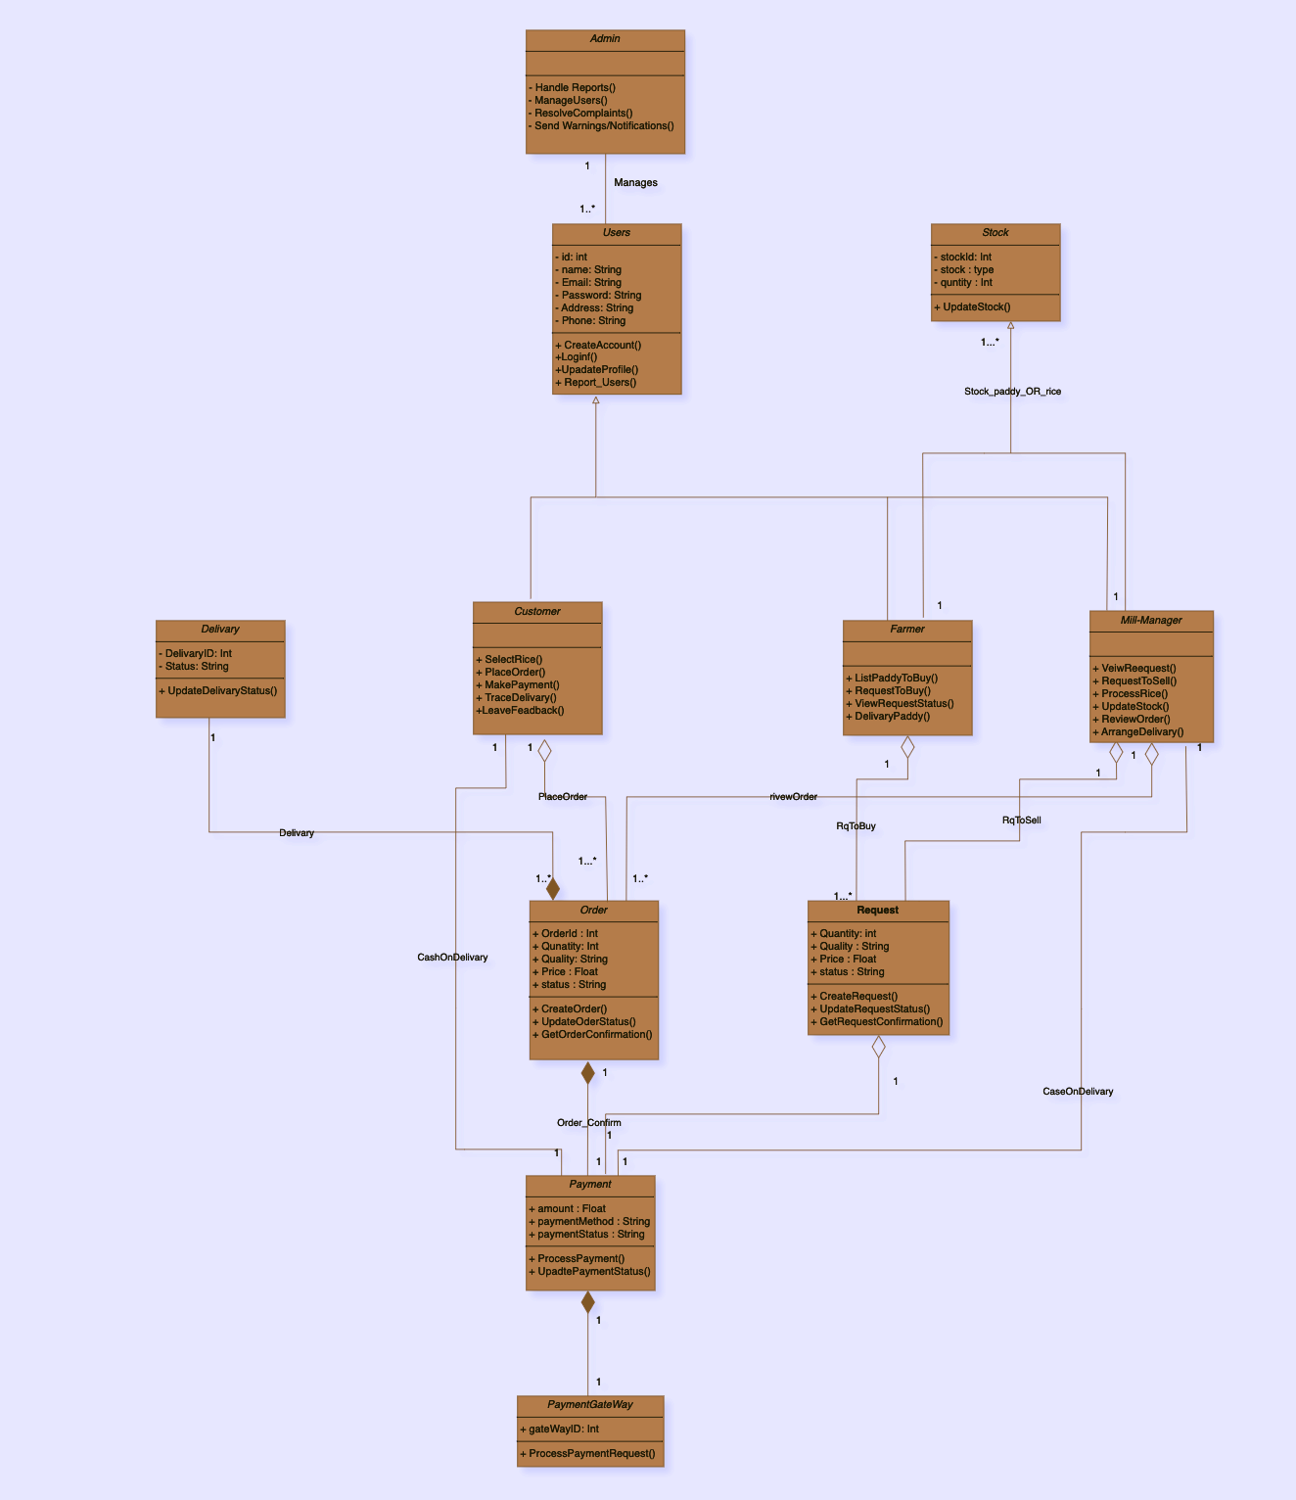

**Chapter 8**

**Sequence Diagram**

**8.1 Farmer**

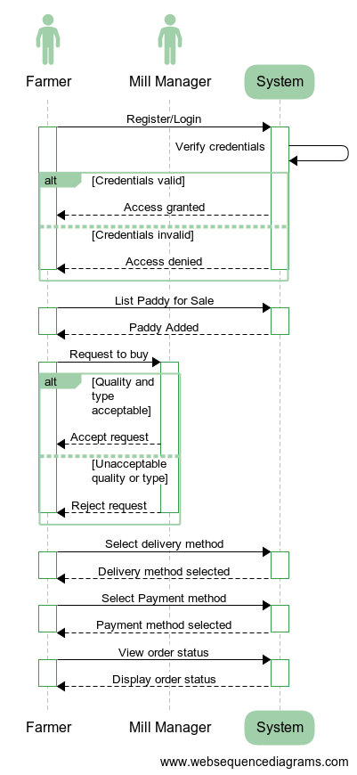

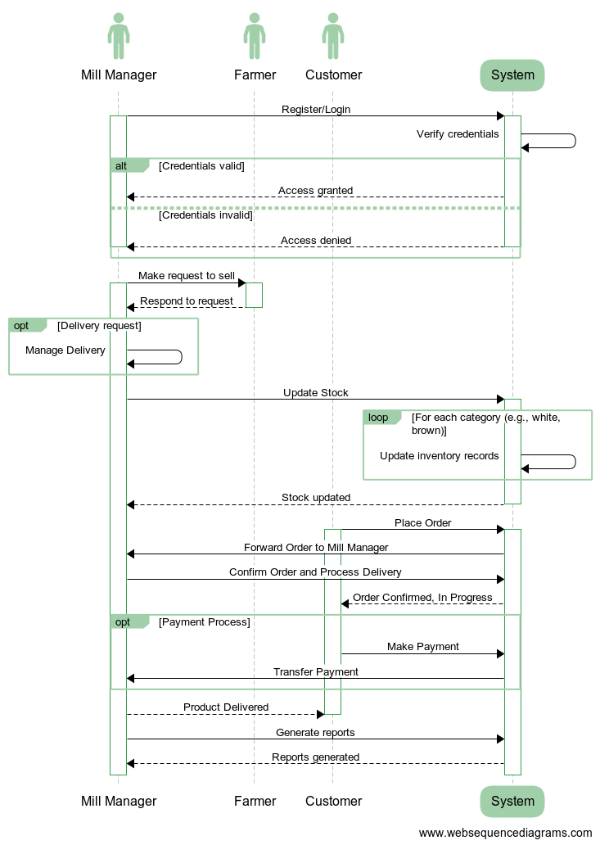**8.2 Mill Manager**

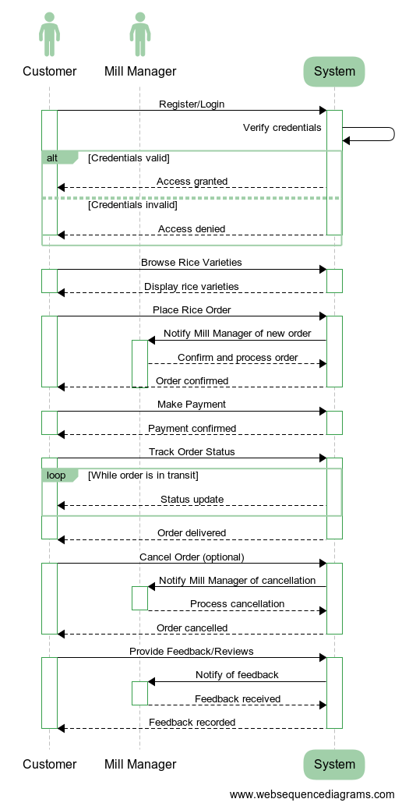**8.3 Customers**

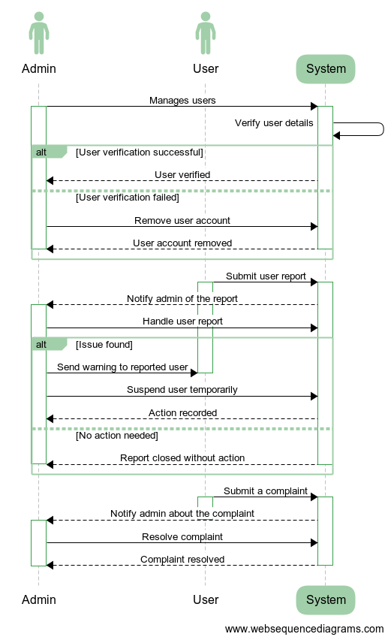**8.4 Admin**

**Chapter 9**

**9.1 State Chart Diagram of Farmers**

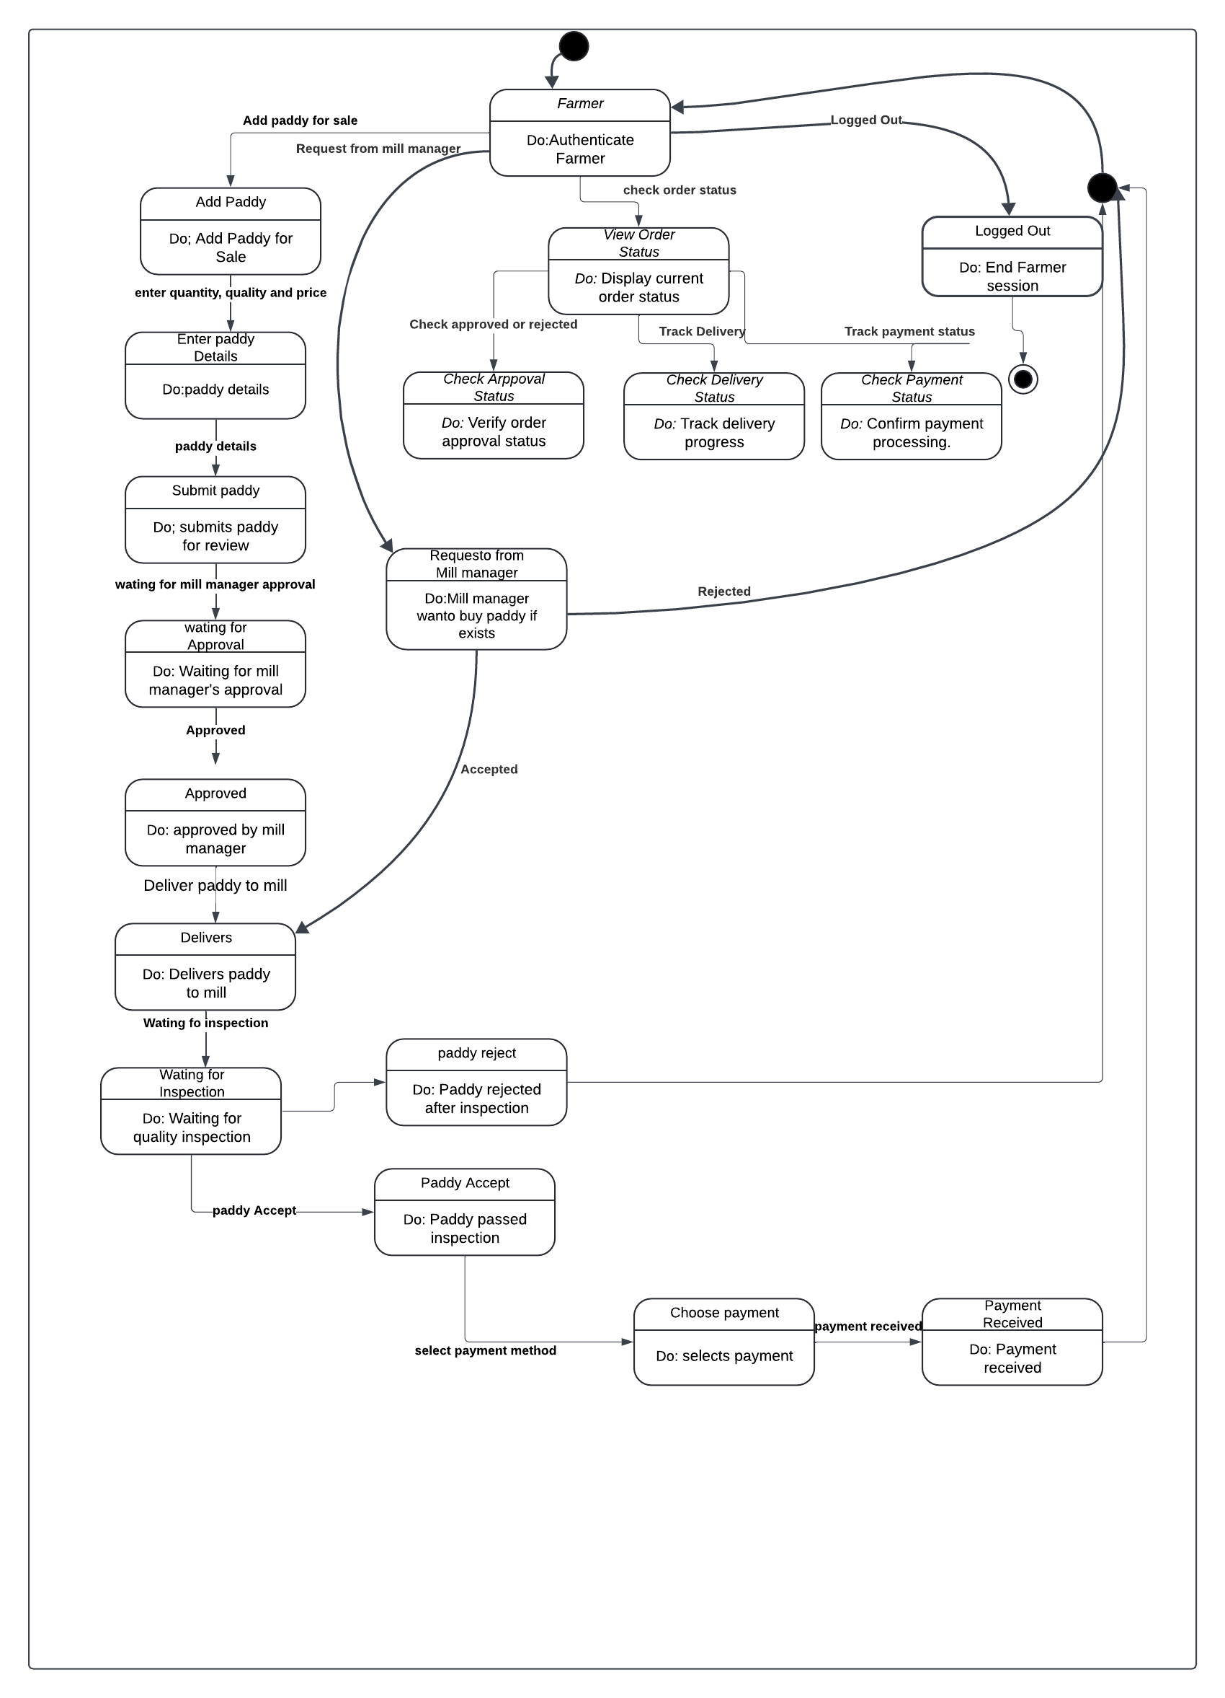

**9.2 State Chart Diagram of Mill Managers**

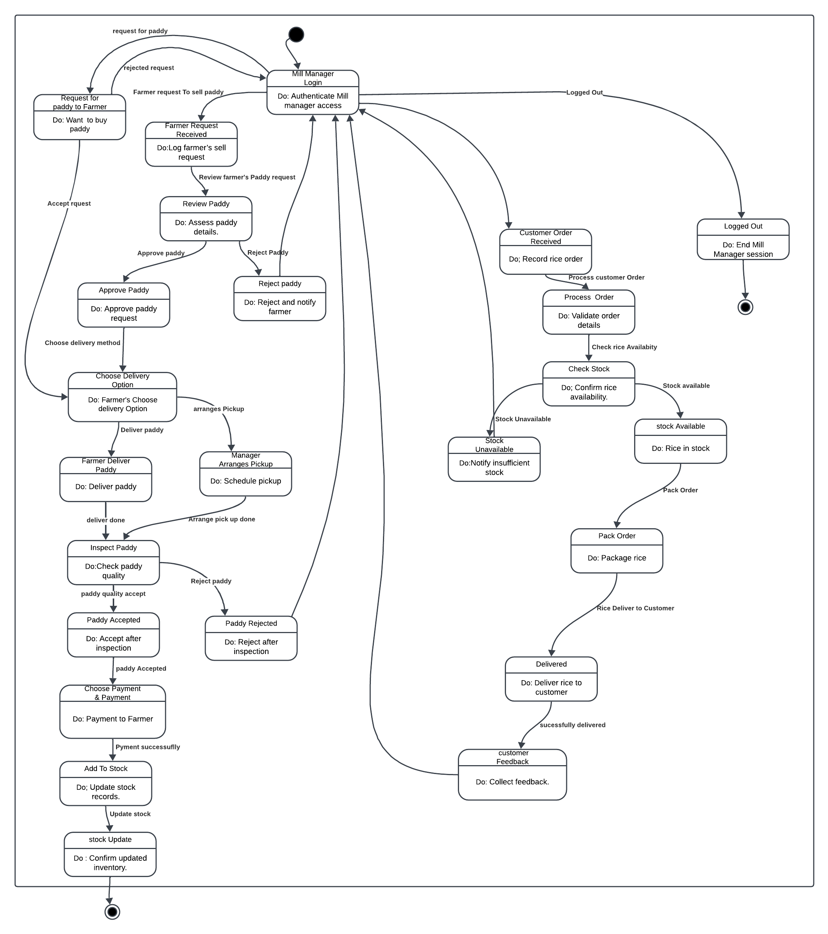

**9.3 State Chart Diagram of Customers**

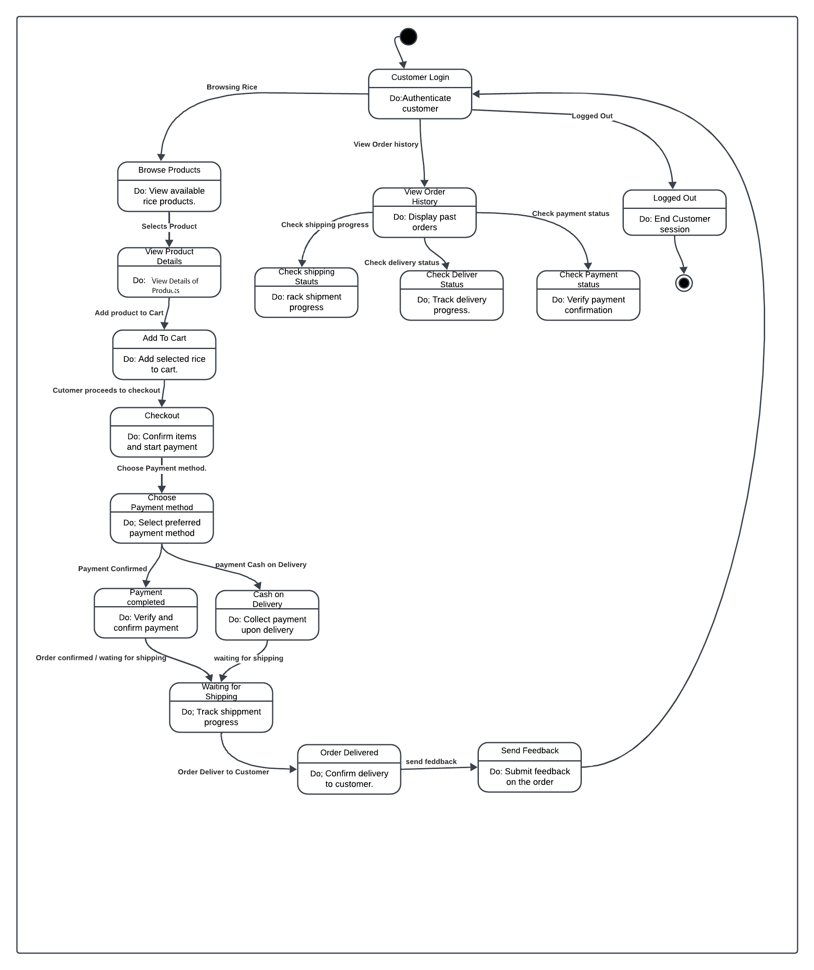

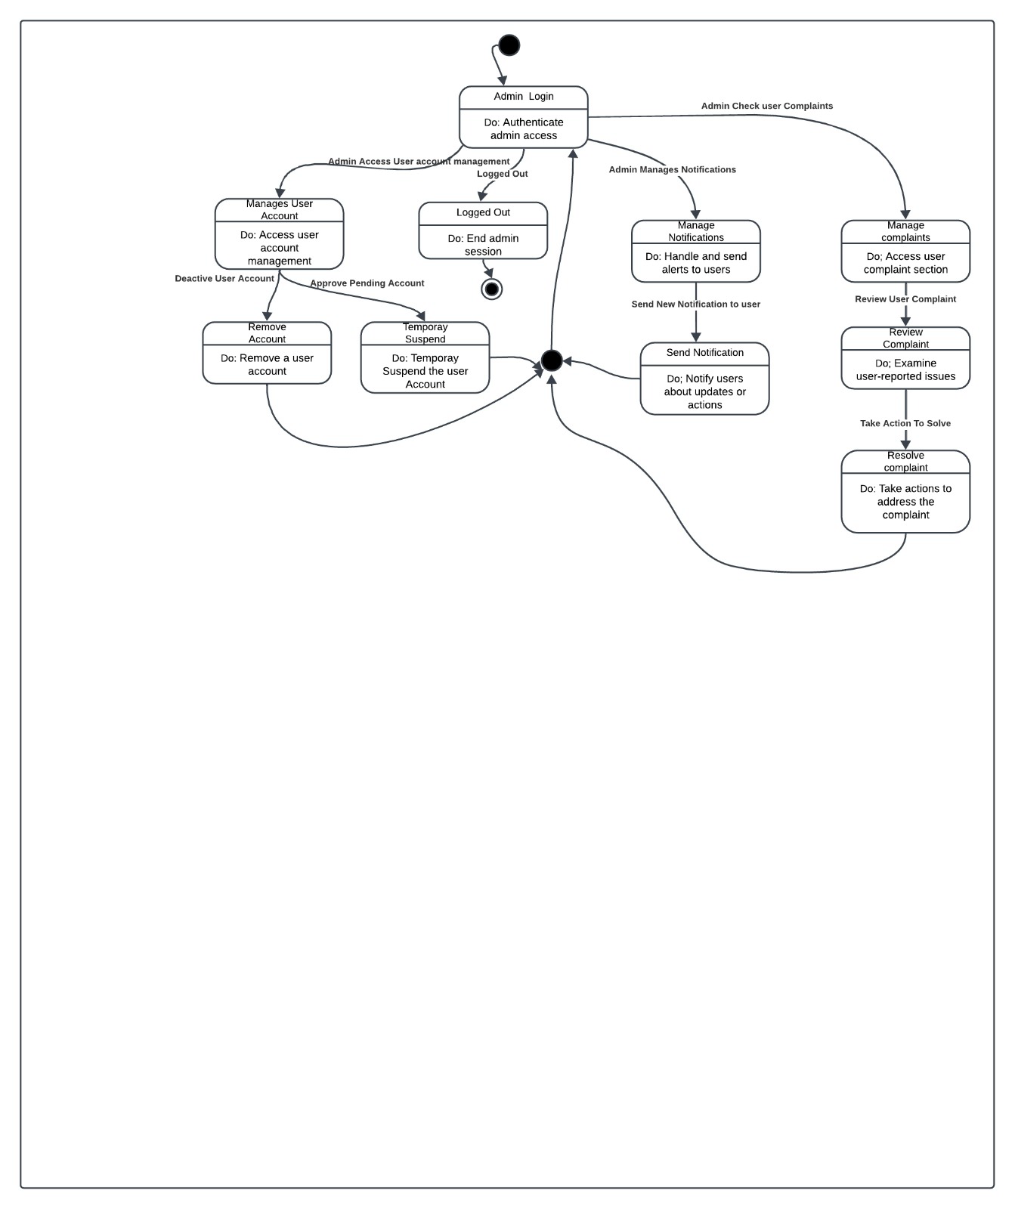**9.4 State Chart Diagram of Admin**

**Chapter 10**

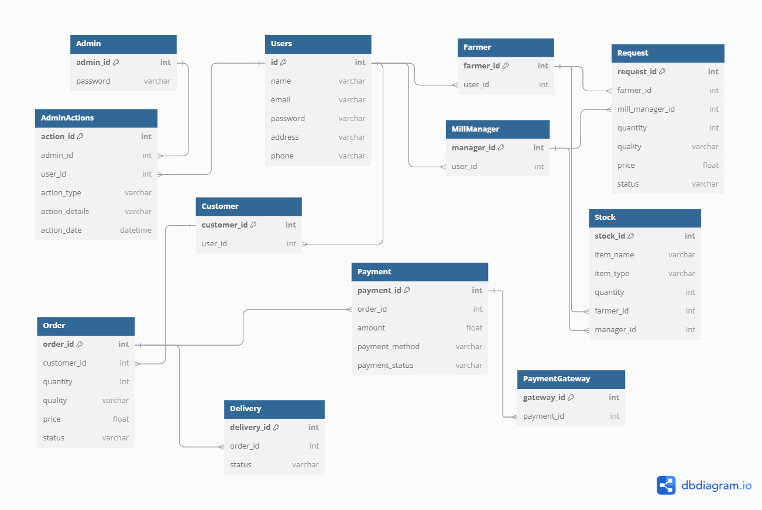**Database Schema**